**SCATTERING PARAMETERS OF BAND PASS FILTER USING ADS**

***A MINIOR PROJECT REPORT***

*Submitted by*

**M. Sai Kishore (171FA05305)**

**R. V. L. Karthik (171FA05329)**

**S. Tushar (171FA05362)**

**in**

**Electronics and Communication Engineering**

*Under the Esteemed Guidance of*

**Mr. M. Chenna Kesava Rao**

**Asst. Professor**



(ACCREDITED BY **NAAC** WITH **‘A’** GRADE)

MHRD **NIRF 88**RANK

**DEPARTMENT OF**

**ELECTRONICS & COMMUNICATION ENGINEERING**

**VFSTR, VADLAMUDI.**

**GUNTUR-522213, ANDHRAPRADESH, INDIA**

**JANUARY 2021.**

**CERTIFICATE**

This is to certify that the minor project report entitled **“SCATTERING PARAMETERS OF THE BAND PASS FILTER USING ADS SOFTWARE”** that is being submitted by **M. Sai Kishore, R.V.L. Karthik, S. Tushar** bearing **regd. No. 171FA05305, 171FA05329, 171FA05362**  respectivelyin partialfulfilment for the award of IV year I semester B.Tech degree in Electronics and Communication Engineering to Vignan’s Foundation for Science Technology and Research , is a record of work carried out by him/her under the guidance of Mr. M. Chenna Kesava Rao, Assistant Professor of ECE Department

Signature of faculty guide Signature of Head of Department

Mr. M. Chenna Kesava Rao Mr.T.Pitchaiah, Ph.D. M.E,MIEEE

Asst.Professor Assoc.Professor, HOD

**ABSTRACT:**

Band pass filters are widely used in wireless transmitters and receivers. The main function of such a filter in a transmitter is to limit the bandwidth of the output signal to the band allocated for the transmission. This prevents the transmitter from interfering with other stations. This project deals with the scattering parameters of band pass filter using ADS(Advanced Design System) software.

|  |  |  |
| --- | --- | --- |
|  |  |  |
|  | **CONTENTS**   |  |  |  | | --- | --- | --- | | **S.NO** | **TOPIC** | **PAGE NO** | | 1 | Introduction | 6 | | 1.1 | Filters | 7 | | 1.2 | Classification of filters | 7 - 10 | | 1.3 | Design procedure | 11 | | 1.4 | Scattering parameters | 11 | | 2 | Software Used | 12 | | 2.1 | ADS Software | 13 | | 2.2 | Procedure using ADS | 13 | | 3 | Circuits and Results | 15 | | 3.1 | Circuit diagram | 16 | | 3.2 | Simulation Results | 16 | | 3.2.1 | Schematic of bpf | 16 | | 3.2.2 | Scattering parameters of bpf | 17 | | 4.1 | Advantages | 18 | | 4.2 | Disadvantages | 18 | | 4.3 | Applications | 18 | |  |
|  |  |  |
|  |  |  |
|  |  |  |

**FIGURES:**

|  |  |  |
| --- | --- | --- |
| **S.No** | **Tittle** | **Page.no** |
| 1 | Low pass filter | 8 |
| 2 | High pass filter | 8 |
| 3 | Band pass filter | 9 |
| 4 | Band stop filter | 10 |
| 5 | Circuit diagram | 16 |
| 6 | Schematic diagram | 16 |
| 7 | Scattering parameters | 17 |

**CHAPTER 1**

**INTRODUCTION**

**1.1 FILTERS:**

Filters are technical realizations of given system functions, which affect the spectral characteristics of an input signal in the main (Frequency selection). In the context of electro-technology, the realizations with electrical networks interest as analogue and digital circuits. Filter applies for the separation of signal components with different frequency ranges e.g. in the telephone, radio communication etc., to the influence of the signal spectrum e.g. by equalizer, sound controller etc., to the suppression of disturbances, e.g. narrow band interference, noise. Analog low pass and bandpass filter are needed as anti-aliasing filter and interpolation filter in digital signal processing.

**1.2 CLASSFICATION OF FILTERS:**

Basic types of frequency-selective filters

• Low pass filter

• High pass filter

• Band pass filter

• Band-stop filter

• All-pass filter AP

**Low pass filter:**

Low-pass filter is a filter that allows signals with a frequency lower than the cut-off frequency (the frequency at which the output voltage is 70.7% of the source voltage) to pass through it. It also attenuates those signals whose frequency is higher than the cut-off frequency.

In other words, low-pass filters help in removing short-term fluctuations, and provide a smoother form of signal.

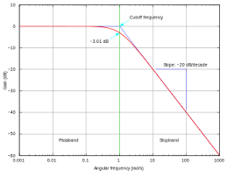

Fig 1: low pass filter

**High pass filter:**

A high-pass filter (HPF) is an electronic filter that passes signals with a frequency higher than a certain cutoff frequency and attenuates signals with frequencies lower than the cutoff frequency. The amount of attenuation for each frequency depends on the filter design. A high-pass filter isusually modeled as a linear time-invariant system. It is sometimes called a low-cut filter or bass-cut filter. High-pass filters have many uses, such as blocking DC from circuitry sensitive to non-zero average voltages or radio frequency devices. They can also be used in conjunction with a low-pass filter to produce a bandpass filter.

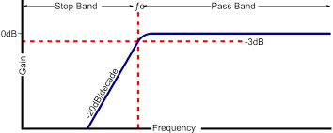

Fig 2 : High pass filter

**Band pass Filter:**

A band pass filter is an electronic circuit or device which allows only signals between specific frequencies to pass through and attenuates/rejects frequencies outside the range. Band pass filters are largely used in wireless receivers and transmitters, but are also widely used in many areas of electronics.

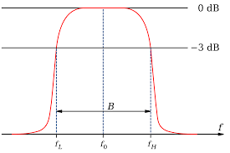

Fig 3. Band Pass Filter

**Band Stop Filter:**

The band stop filter is formed by the combination of low pass and high pass filters with a parallel connection instead of cascading connection. The name itself indicates that it will stop a particular band of frequencies. Since it eliminates frequencies, it is also called as band elimination filter or band reject filter or notch filter. We know that unlike high pass and low pass filters, band pass and band stop filters have two cut-off frequencies. It will pass above and below a particular range of frequencies whose cut off frequencies are predetermined depending upon the value of the components used in the circuit design.

Any frequencies in between these two cut-off frequencies are attenuated. It has two pass bands and one stop band.

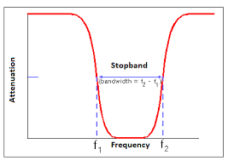

Fig 4: Band stop filter

**All pass filter:**

An all-pass filter is a signal processing filter that passes all frequencies equally in gain, but changes the phase relationship among various frequencies. Most types of filter reduce the amplitude (i.e. the magnitude) of the signal applied to it for some values of frequency, whereas the all-pass filter allows all frequencies through without changes in level.

**1.3 Design Procedure:**

Ro=50

f1C=2.4GHz

f2C=2.6GHz

Ls= (Ro / (pi*(f2C – f1C))) /2

Cs = 2*(f2C – f1C) / (4*pi*Ro*f2C*f1C)

Lp= 2*Ro*(f2C – f1C ) / (4*pi*f2C*f1C)

Cp=(1/(pi*Ro*(f2C – f1C)))/2

**1.4 Scattering Parameters:**

S (scattering) parameters are a well-known circuit analysis technique from RF and microwave electronic designers for linear multiport networks. In these applications, designers usually work with power and impedance.

Low frequency designers work with other parameters as Z (impedance), Y (admittance), and H (hybrid). They usually work (are familiar) with voltage and current.

But, from a theoretical point of view all those parameters are equivalent. They can predict the response of any linear (active or passive) network when you connect at the input and output ports any other signal and termination impedances.

S-parameters in the analysis of a filter for all of you who are not familiar with this kind of tool because for high frequencies, as in EMI design, S-parameters are very useful (voltage and currents are difficult to measure).

**CHAPTER – 2**

ADS SOFTWARE

**2.1 ADS SOFTWARE:**

* Advanced Design System (ADS) is an electronic design automation software system produced by Key sight of EDA a division of Key sight Technologies. It provides an integrated design environment to designers of RF electronic products such as mobile phones, pagers, wireless networks, satellite communications, radar systems, and high-speed data links.
* Keysight ADS supports every step of the design process—schematiccapture, layout, design rule checking, frequency-domain and time-domain circuit simulation, and electromagnetic field simulation allowing the engineer to fully characterize and optimize an RF design without changing tools.
* Keysight EDA has donated copies of the ADS software to the electrical engineering departments at many universities
* Complete schematic capture and layout environment.
* Innovative and industry leading circuit and system simulators.
* Largest number of process design kits (PDKs) developed and maintained by leading industry partners.

**2.2 PROCEDURE USING ADS:**

**STEP1: Start up ADS and create your workspace**

Choose your directory and name your workspace.  Select only the Analog/RF library, and uncheck all others if needed.  This means that the components from the RF/Analog library will be available for later. Name your library, and select the Standard ADS Layers .0001 mil layout resolution.  Make sure everything looks correct, and click “Finish”.. Your workspace is now created!

**Step 2:  Build your schematic**

By expanding to cell view, you can now see that your schematic pops up in your workspace. Select the components you need by clicking on the component and dropping it on the schematic page.  You can rotate parts by using the tool bar icon or cursor on or use the cursor to drag the handle on the component.  Connect up the components with the wire button, and don’t forget to ground your circuit! To change the values, units, or even the name of your component, double-click the component and make changes as needed.

**Step 3:  Set up an S-Parameter Simulation**

Select the “Simulation S-Param” on the palette and drop it on your schematic area.  Insert the port terminations, and make sure to ground them. To set up the simulation, double-click the gear on the schematic. Change the step size and frequency range.  I used a step size of 0.01GHz going from 0.1 GHz to 10 GHz.  Click OK, and now you are ready to simulate! Click the gear (alternatively, use F7), select simulate, and fix any errors that may have shown up.ADS has a variety of different plots.  I’m going to create a rectangular plot. Select the rectangular plot and select which S-parameter measurement you want to use, select your units (S-parameters are usually measured in dB), and click ok. You can zoom in and out with your mouse, and view all with this icon: Put a marker on the trace, and you can move them around with the red arrows.

**CHAPTER – 3**

**CIRCUIT DIAGRAM**

**AND**

**SIMULATION RESULTS**

**3.1 CIRCUIT DIAGRAM:**

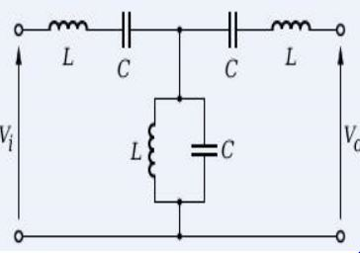

**Fig 5: Circuit diagram of band pass filter**

**3.2 SIMULATION RESULTS:**

**3.2.1 Schematic of band pass filter**

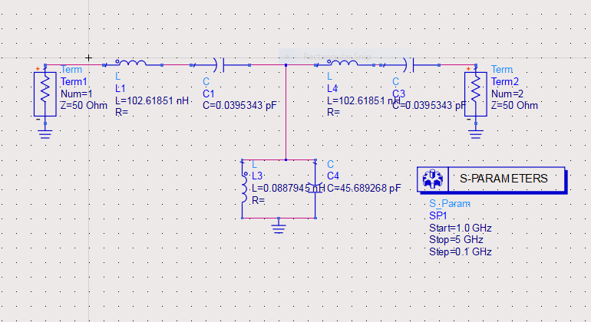

**Fig 6: Schematic of band pass filter**

**3.2.2: Scattering parameters of band pass filters:**

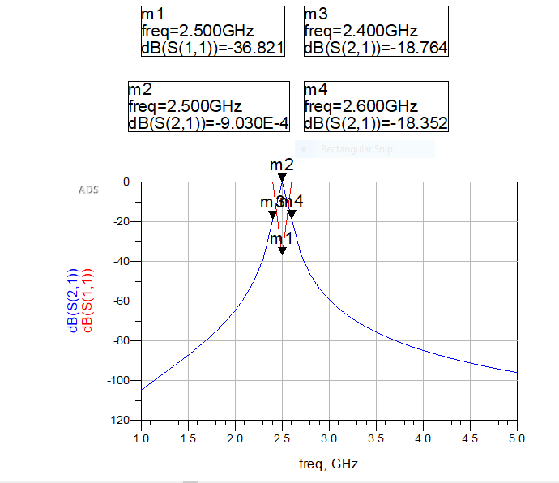

**Fig 7 : Scattering parameters of band pass filter**

**4.1 ADVANTAGES:**

* Band pass filters are small size and excellent electrical performance with extended stop band rejections in a stand alone band pass filter.
* Excellent frequency and temperature
* Stability
* Low insertion loss and VSWR and sharp selectivity

**4.2 DISADVANTAGES:**

* Narrow bandwidth
* Lower gain
* Low power handling capacity
* Low efficiency

**APPLICATIONS:**

* Wireless transmitters and receivers
* Widely used in optics such as lasers
* Communication systems
* Audio signal processing

**CONCLUSION:**

Therefore, BAND PASS FILTER is designed and scattering parameters of BAND PASS FILTERS are obtained using ADVANCED DESIGN SYSTEM software.

**REFERENCES:**

[1] https://www.electronicshub.org/passive-band-pass-rc-filter

[2] https://www.electronics-tutorials.ws/filter/filter_4.htm

[3] https://www.electronics-notes.com/articles/radio/rf-filters/constant-k-simple-bandpass